**Futsal Management System**

Roshan Lamichhane, Rahul Poddar, Nirajan Bhattarai, Rishan Shrestha, Binju Rai

Bsc.(Hons.) Computing, Softwarica College of IT and E-commerce, Coventry University

ST4008CEM Computing Activity LED Learning Project 2

Albert Maharjan

8th December 2023

Table of Contents

Introduction 4

Keywords 5

Aim 6

Objectives 6

Problem Statement 7

Solution 7

Functionalities 8

Functional Requirements 8

Non-Functional Requirements 9

Tools and Technologies 10

Methodology 11

Working Mechanism 14

Literature Review 16

Conclusion 18

SWOT Analysis 19

Appendix 20

Reference 21

**Table of Figures**

Figure 1 Agile Methodology 11

Figure 2 SWOT 19

Figure 3 Login Page 20

Figure 4 Registration Page 20

# Introduction

Presenting the Futsal Management Application, a noteworthy arrangement that changes the way futsal lovers engage in with their favorite sport. Our app, developed with the user in mind, makes it simple for users to find, reserve, and manage futsal venues while keeping track of their booking history. On the administrative side, the app provides a suite of tools, allowing administrators to efficiently handle booking requests, approve new futsal venue additions, and maintain a detailed user list for streamlined communication. Futsal application imagines a consistent combination of enthusiasm and productivity, making an energetic local area where the affection for futsal flourishes.

Join us as we revolutionize the futsal experience by bringing fans and administrators together on one platform. The Futsal Management App is more than just a program; it opens the door to a future where futsal fans can enjoy unparalleled convenience and administrators can optimize their operations for a management process that is more effective and well-organized. Go along with us at the crossing point of enthusiasm and innovation, where the round of futsal becomes the overwhelming focus more than ever.

# Keywords

* Management System
* Futsal Venue
* Favorites
* Booking
* Booking Verification
* Agile
* Organized
* Futsal Request
* User Friendly
* Record Keeping
* Registration

# Aim

The aim of our project is to develop an innovative and comprehensive solution that seamlessly connects futsal enthusiasts with facility administrators and simplify the futsal experience for users by providing an intuitive platform to discover, book, and manage futsal venues.

# Objectives

* To implement a workflow for users to request the addition of new futsal venues to the platform.
* To provide administrators to review and approve these requests, ensuring the continuous growth of the app's venue database.
* To enable users to access a comprehensive and transparent booking history, allowing them to track and manage their futsal activities over time.
* To provide administrators for verification and response to booking requests, including options for acceptance or rejection.
* To provide intuitive interface for users to easily browse and explore a list of futsal venues.

# Problem Statement

In the current scenario of futsal management systems, enthusiasts and facility managers face many challenges that hinder the optimal utilization of available resources. Users often deal with fragmented information role when searching for suitable soccer venues, they face challenges to navigate through separate meetings to verify availability, timing and registration process gets burdened with shale equipment, with the cause of communication gap is facility poor management. Existing systems lack a unified and user-friendly interface that effectively integrates the needs of football enthusiasts and facility managers emphasizing the urgent need for a solution emphasizing comprehensiveness and simplicity. Our business goals are to address these deficiencies, a new Futsal Management App is provided to address these gaps and enhance the overall football experience users and managers.

# Solution

To address the current challenges in football management, we launched an innovative Futsal Management App designed to transform the user experience for enthusiasts and office managers alike. This new solution eliminates fragmented site searches, simplifies the authentication process, reduces the burden of the registration process caused by different tools and methods, and the app boasts connectivity unified and user-friendly, ensuring effective integration of user and facility manager needs. Prioritizing comprehensive and flexible solutions our objectives is to overcome issues of poor records, lack of stakeholder focuses and communication gaps Futsal Management App. We are ready to provide systems improve internal conflicts prevent abuse of resources, and enhance the overall experience for users and management.

# Functionalities

## Functional Requirements

* Authentication and Registration:

Creating accounts and log in security ensuring a personalized experience is given within the futsal management app.

* Futsal Venues:

Information about available futsal venues including details like location and facilities are provided for the users.

* New Futsal Request:

The users can submit requests for new futsal venues to the admin.

* Futsal Booking:

Enables users to browse book futsal venues, and receive instant confirmations, streamlining the booking process.

* Favourites:

Users can save their preferable futsal venues for quick and easy access, enhancing user convenience and personalizing the experience of the app.

* Booking History:

Futsal records of previously booked games are shown, which will help users track their usage history and make it easier to clearly display for future bookings.

* User Management:

It empowers users to manage their profiles, including personal information, preferences, and account settings, to ensure a personalized experience.

* Futsal management:

It provides management tools for administrators, allowing them to manage and update venue information, view booking analytics, and optimize facility operations.

## Non-Functional Requirements

* Reliability
* Security
* Localization
* Performance
* Usability

# Tools and Technologies

* Windows
* MAC
* VScode
* MySQL
* Figma
* Java
* Git
* GitHub
* MS Word
* MS Excel
* NetBeans

# Methodology

Agile is a project management style that emphasizes incremental improvement and iteration, breaking down projects into short-term cycles of rapid delivery and change. It promotes collaboration and continuous feedback; it enables teams to adapt to challenges and stakeholders to communicate regularly. Originally developed for software development, Agile has spread to various industries and organizations. In contrast, traditional project management follows a horizontal progression through design, planning, implementation, and closing lessons, where each stage must be completed before moving on to the next. This method does not have the flexibility and flexibility of the agile method.

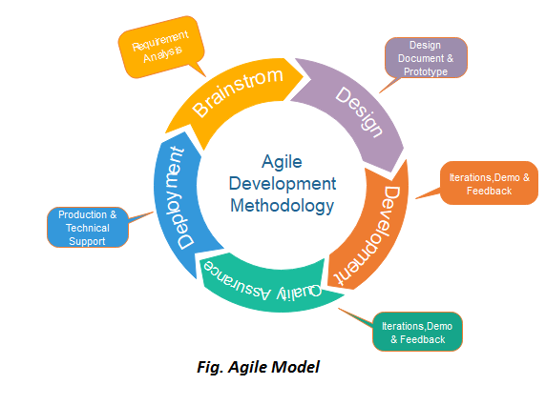

Figure 1 Agile Methodology

Why use Agile Methodology?

1. Adaptability to Change:

The fast-paced development environment allows for continuous feedback and adaptation based on user needs and market changes. This ensures your app remains relevant and competitive.

Agile embraces early and frequent releases, enabling you to test features and gather user feedback quickly, iterating and improving the app with each sprint.

1. Faster Time to Market:

Agile's short development cycles allow you to launch your app sooner, capturing market share and user engagement faster.

Continuous testing and feedback during development cycles help identify and fix issues early, preventing costly delays and rework in later stages.

1. Enhanced Collaboration and Visibility:

Agile promotes close collaboration between developers, designers, and users, fostering a shared understanding of goals and priorities.

The transparent nature of agile methodologies, with regular meetings and reporting, provides stakeholders with clear visibility into progress and potential challenges.

1. Improved Quality and Control:

Agile's iterative approach allows for continuous testing and improvement throughout the development process, leading to a higher quality app with fewer bugs.The focus on small, manageable tasks facilitates better control over the development process, allowing for quick adjustments and risk mitigation.

1. Reduced Risk and Cost:

Agile's emphasis on early delivery and user feedback helps identify and address potential issues early, reducing the risk of costly rework and delays in later stages.

The flexible nature of Agile allows for adjusting project scope and budget based on evolving needs and priorities, mitigating unnecessary risks and financial burdens.

1. Increased User Satisfaction:

Agile's focus on user needs and continuous feedback ensures the app is designed and developed with user satisfaction as a top priority.

Early and frequent feedback loops allow for incorporating user suggestions and addressing concerns promptly, leading to a more user-centric and satisfying experience.

# Working Mechanism

1. User Registration and Profile Creation:

Users initiate their journey by registering on the app, creating personalized profiles that include relevant information such as preferences and contact details.

1. Venue Discovery:

Utilizing a user-friendly interface, enthusiasts can explore a curated list of futsal venues based on location, amenities, and availability.

1. Booking Process:

Users select their desired futsal venue, check real-time availability, and proceed to book a slot using the intuitive booking system. The app provides a transparent overview of pricing and timings.

1. Favorites Feature:

Users have the option to mark and save their preferred futsal venues as favorites, creating a personalized list for quick access in the future.

1. User Communication:

The app facilitates clear and direct communication that allows users to receive booking confirmations, updates on their requests, and relevant information from the futsal facility.

1. Administrator Verification and Approval:

When a booking request is made, administrators receive prompt notifications and utilize efficient tools to verify and respond to requests, either accepting or rejecting them.

1. User History Tracking:

The app maintains a transparent and accessible booking history for users, allowing them to track and manage their futsal activities over time.

1. Facility Addition Workflow:

Facility owners can request the addition of new futsal venues to the app. Administrators review and approve these requests, ensuring a continuous expansion of the app's venue database.

# Literature Review

This literature review aims to explore existing research and publications relevant to the development of a mobile application for booking futsal courts. The review will focus on identifying key findings and trends related to user needs, existing solutions, and potential challenges in the market.

1. **User Needs and Preferences**

Understanding the needs and preferences of futsal players is crucial for developing a successful booking app. Several studies have investigated user behavior and motivations regarding booking sports facilities.

* Convenience: Users prioritize ease of booking and access to information about futsal courts.
* Flexibility: Users desire flexible booking options, including last-minute booking and cancellation policies.
* Filters and Reviews: Users seek filtering options based on location, availability, price, and user reviews.
* Payment Integration: Secure and convenient online payment methods are essential.
* Social Interaction: Users might appreciate features like connecting with other players or creating teams.

1. **Existing Solutions and Market Analysis**

Several futsal booking apps are available in the market, offering various features and functionalities.

* Features: Popular features include online booking, court availability, user profiles, booking history, and push notifications.
* Market Growth: The futsal booking market is expected to grow significantly in the coming years.
* Competition: Existing competitors offer different value propositions and target diverse audience segments.

1. **Challenges and Opportunities**

Developing a successful futsal booking app requires careful consideration of potential challenges and opportunities.

* Competition: Differentiation from existing players is crucial for capturing market share.
* User Adoption: Effective marketing and user acquisition strategies are necessary.
* Technology Integration: Integration with payment gateways and other services requires careful planning.
* Security and Privacy: Ensuring user data security and privacy is paramount.

# Conclusion

In conclusion, the Futsal Management App stands as a pioneering solution that redefines the futsal experience for enthusiasts and administrators alike. With a user-friendly interface, efficient booking processes, and transparent communication channels, the app empowers users to seamlessly discover, book, and manage their preferred futsal venues. The incorporation of innovative features such as availability updates, favorites, and a comprehensive booking history enhances user satisfaction and convenience. Administrators benefit from robust tools for streamlined verification, approval workflows, and user management, ensuring operational efficiency. The app's scalability, adaptability, and commitment to user feedback underscore its dedication to continuous improvement. As the Futsal Management App bridges the gap between passion and efficiency, it aspires to become the go-to platform for futsal enthusiasts and administrators, fostering a vibrant and cohesive community where the love for the sport thrives effortlessly.

# SWOT Analysis

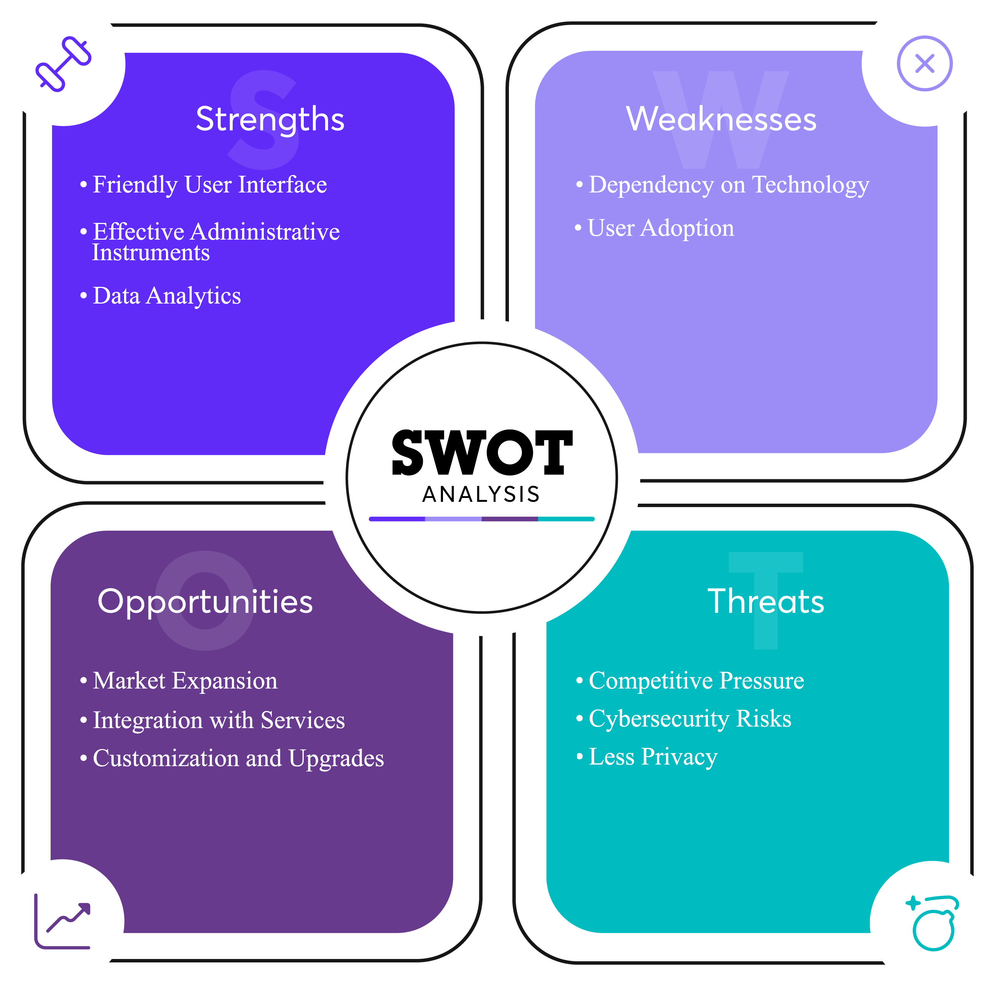

Figure 2 SWOT

# Appendix

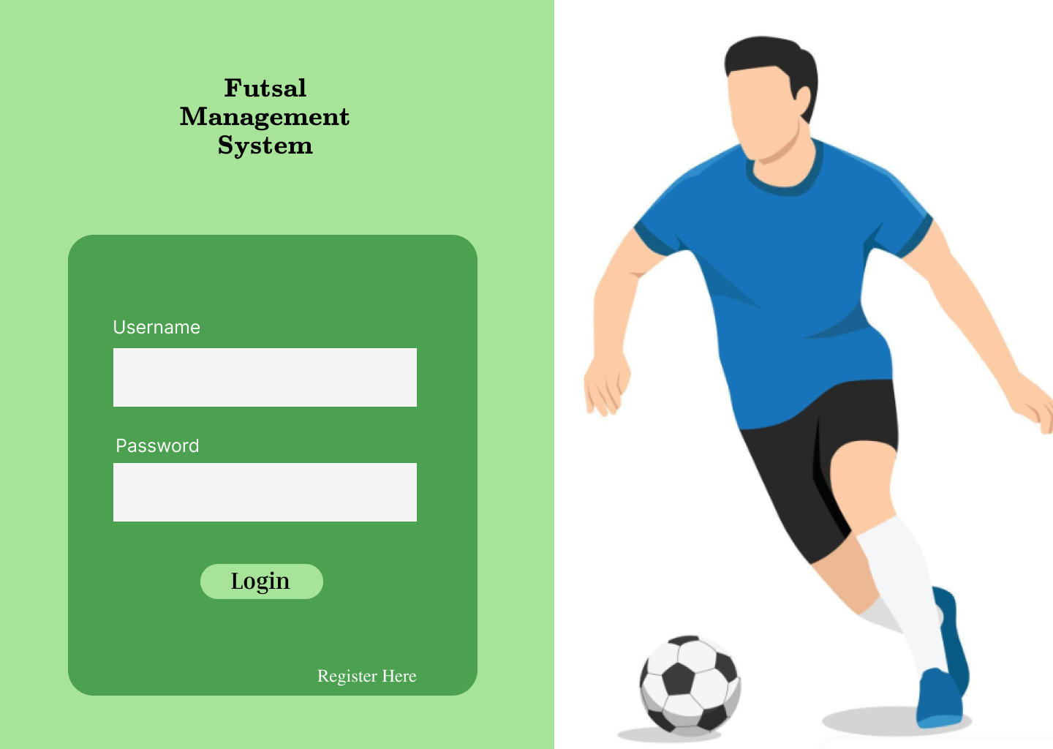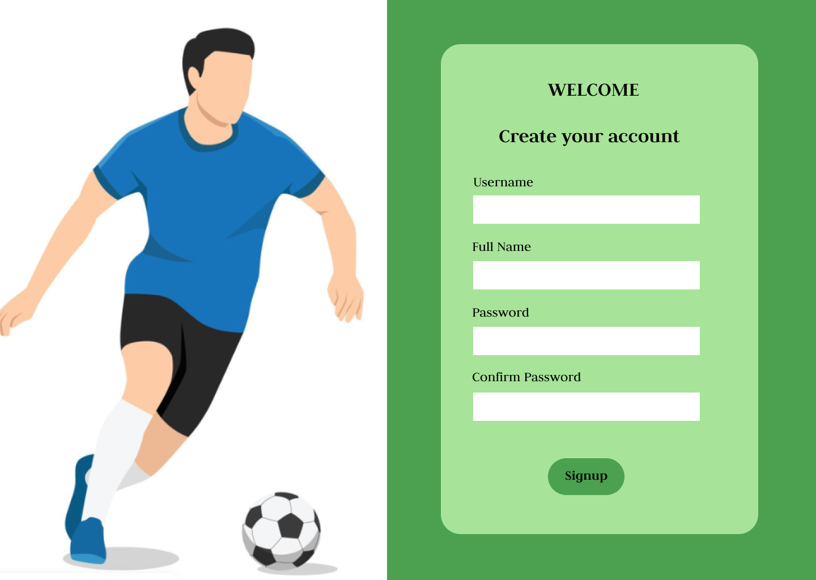

Figure 3 Login Page

Figure 4 Registration Page

# Reference

1. Agile Model <https://www.javatpoint.com/software-engineering-agile-model>
2. A Survey of Mobile Apps for Booking Sports Facilities" by Zhang, Y., Guo, Y., & Chen, X. (2022). Journal of Sports Science and Medicine, 21(3), 523-532
3. User Preferences for Booking Sports Facilities: A Mobile App Perspective" by Lee, J., Lee, J., & Park, J. (2021). Proceedings of the ACM SIGCHI Conference on Human Factors in Computing Systems, 2021(1), 1-13.
4. "A Comparative Analysis of Popular Futsal Booking Apps" by Singh, A., & Kumar, R. (2022). International Journal of Mobile Computing and Telematics, 14(4), 54-62
5. "Challenges and Opportunities in Mobile App Development for Sports Booking" by Sharma, S., & Singh, G. (2021). International Journal of Engineering and Advanced Technology, 10(6), 321-325.
6. Why Agile Methodologies Work: <https://hbr.org/2016/05/embracing-agile>